Implementation Guide Header
Tech Goods | Siebel Log Parser |  |  |  |  | Version | 2.3.0
Description | Siebel Log Parser is tool for parsing Siebel log files and displaying information about workflow processes and signals executions, raised warnings, errors and long running SQLs. Data is displayed in treeview with input/output information. Supported Siebel versions are 7.7 - 8.2.
Category | Tool | Target Region | Global | Industry | ALL
Contributor | Peter Cisko |  |  | Reviewer

Industrialization Factors
Reduction Factor |  | Analyze | No | Design | No | Build | 10-30% | Test | 10-30%
Credential | The effort saving are up to 30% in Build and Test phase. Decreased time to debug workflow processes, signals. Decreased time for workflow performance tuning and searching long running queries. Decrease time to identify user actions.

Obligatory Requirements
Siebel Version | 7.7 - 8.2 | Support Package | -
Dependent Tech Goods

Last Change Description
Version | Modified in | Responsible | Modification
2.1.4 | 25 July 2013 | Peter Cisko | - Tool published
2.2.0 | 29 Nov 2013 | Peter Cisko | - Performance improvements for files with log level 5.  - Parsing Workflow, WebService and EAI performance information for ENU language.  - Enhanced TBUI steps parsing for ENU language.  - Fixed issue for parsing SQL based on time value.  - Minor fixes.
2.3.0 | 26 May 2014 | Peter Cisko | - SQL reformating using bind variables for ENU language.  - Added posibility to reopen recent files.  - Parsing Runtime Property value for ENU language.  - SQL steps displays SQL Cursor fetch.  - Added find toolbar.  - Added possibility to hide menu toolbars and save this configuration.

Table of Contents
1. General Description 3
2. Installation Procedure 4
2.1 Pre-Requisites 4
2.2 Installation Process 4
3. User Guide 5
3.1 Login Credentials 5
3.2 Utilization Procedure 5
3.3 Artifact Functionalities 6
3.4 Error Handling 7
4. Attachment Guide Content 8
5. Version Change Log 8

General Description
Siebel Log Parser is tool for parsing Siebel log files and displaying information about workflow processes and signals executions, raised warnings, errors and long running SQLs. Data is displayed in treeview with input/output information. Supported Siebel versions are 7.7 - 8.2.

Installation Procedure

Pre-Requisites
Before the installation of this Technical Goods, you need to install the following objects:
Technical Goods Code | Description | Version
.NET Framework 4.0 | .NET Framework | 4.0

If the pre-requisites are not present on system during installation of this Technical Goods you will face an error message and this installation will fail.

Installation Process
Unzip package and run setup.exe from install directory. Follow steps in installation wizard.

User Guide

Utilization Procedure

Siebel Log Parser application consists of three sections:
- Menu – configuration of Siebel Log Parser
- Process tree – tree view displaying log items based on configuration.
- Properties – section displays additional information for particular item in process tree.

File Menu:
- Open – open Siebel log. Other possibilities how to open log file with Siebel Log Parser are:
  - Drag & Drop – drag and drop file to Siebel Log Parse Application.
  - Open with – run Siebel Log Parse application with full file path as argument
- Run Parser – run file parsing
- Exit – close Siebel Log Parser

Edit Menu:
- Find – find entered text in:
  - Current Properties – current text in property window
  - All Properties – property window text for all process tree items
  - Process Tree – process tree items
- Copy – copy selected text in property window to clipboard
- Select All – select all text in property window

Configuration Menu:
- Workflow – on/off displaying of workflow processes and tasks
- Signal – on/off displaying of raised signals
- Error – on/off displaying of errors
- Warning – on/off displaying of warnings
- SQL – on/off displaying of long running SQL commands (time in seconds entered in textbox)
- Wait – on/off displaying of log waits (time in seconds entered in textbox)
- SWE – on/off displaying SWE commands.
  - Limited – mostly used commands:
    - Login
    - ExecuteLogin
    - GotoView
    - GetViewLayout
    - GotoPageTab
    - InvokeMethod
  - All – all SWE commands
- Performance – on/off displaying of performance information
- Expand – expand whole process tree after log file processing
- Language – set language of log file. Currently supported languages: ENU, SVE, CSY, FRA, ITA, DEU, RUS, PTG, NLD, ESN, FIN.
- Property Window – formatting of property window:
  - Rich Text – formatted text
  - Plain Text – not formatted text
- Parse After Load – on/off parsing log file after load
- Save Configuration – save current configuration
- Default Configuration – load default configuration

Help Menu:
- About Siebel Log Parser

Process tree:

Siebel Log Parser displays process tree items based on configuration. Following data can be displayed:
- Workflow:
  - – Name of the workflow process which was executed. Execution time in seconds is in square brackets.
  - – Name of the sub task which was executed.
  - – Name of the step which was executed. Execution time in seconds is in square brackets. Total SQL time in seconds is in curly brackets. ( - Sub workflow, - Business Service, - Siebel Operation, - Other type). Additional information will be displayed in the properties section.
  - - Name of the Task view
  - – Input arguments (colour depends on WF step). Detail information will be displayed in the properties section.
  - – Output arguments (colour depends on WF step). Detail information will be displayed in the properties section.
  - – Setting Runtime Property. List of runtime properties is displayed in the properties section.
- Signal:
  - – Name and mode of the signal which was raised. Execution time in seconds is in square brackets.
- Error:
  - – Error messages. Detail information will be displayed in the properties section.
- Warning:
  - – Warning messages. Detail information will be displayed in the properties section.
- SQL:
  - – Business component name and SQL operation time will be displayed with execution time more than defined time in seconds. SQL command will be displayed in the properties section.
- Wait:
  - – Wait time between two records in log file which is more than defined time in seconds. Part of log where wait occurred will be displayed in the properties section.
- SWE:
  - – Name and main parameter of the SWE Command. All SWE parameters are displayed in properties section.
- Performance:
  - – Name and performance details:
    - WF: Workflow Name, Number of executions, Total time in miliseconds
    - WS: Webservice operation with time in miliseconds
    - EAI: Operation name, Number of executions, Total time in miliseconds

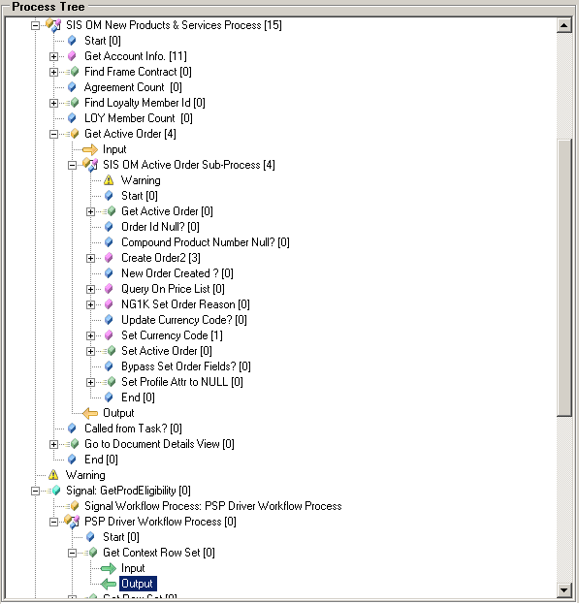

Figure 1 - Process tree
Properties:
Additional information for process tree item is displayed in Properties section. Based on process item type following information will be displayed:
- Workflow/Step input and output – Workflow/step process properties in XML structure. NOTE: Some of data cannot be parsed. Text “Invalid Input/Output.” Will be displayed for these data.
- Workflow steps – Information about executed step like name of invoked business service, sub-workflow, passed branches, etc.
- Error – error message from log file
- Warning – warning message from log file
- SQL – SQL command with execution time
- Wait – rows from log file where wait occurs
- SWE – SWE Command parameters

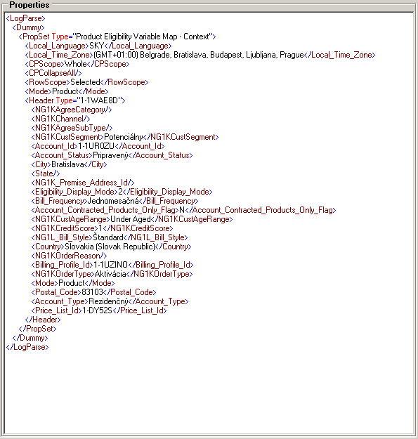

Figure 2 - Properties section

Siebel Log Level
Because parser using information from Siebel object manager log file, it is necessary to set-up correct log level for particular events on object manager. Following table summarize minimal log level of events which have to be set for correct parser processing:

Table 1: Log level
Process tree item | Event Name | Minimal Log Level
Workflow process execution | PrcExec | 4
Workflow step execution | StpExec | 4
Signal execution | GenericLog | 3
Error | All | 1
Warning | All | 2
SQL | ObjMgrSqlObjLog  ObjMgrSqlLog | 4
Process Request Event | ProcessRequest | 4
Task Navigation | TskNav | 4
Event Context | EventContext | 4
Performance | WebSvcPerf  EAISiebAdptPerf  EAITransportPerf  WfPerf | 4

Usage procedure
- Run application.
- Configure parser based on requirement what data need to be displayed.
- Set language of log file.
- Open log file using File > Open.
- Click on ‘Run Parser’ button. Progress of file parsing will be displayed in status bar.
- Status bar text will be changed back to “Ready” when file was processed. Result is displayed in Process Tree section.
- Navigate through Process tree section steps to display detailed information in Properties section.

Artifact Functionalities
Siebel Log Parser is a tool for parsing Siebel log files.
It allows quick analyze of:
- Workflows with their steps, inputs and outputs.
- Execution time of workflows and workflow steps
- Signals executions
- SQL executions and their time
- TBUI flows
- Warning and Errors
- SWE commands
- Performance of Workflows, WebServices and EAI Operations

Error Handling
These are the possible errors that can be returned to the users and how to handle them:
Type | Error | How to Handle
Wrong Input/Output | Invalid Input/Output. | Some Input/Output properties cannot by parsed to xml structure. For such properties error “Invalid Input/Output.” is displayed in properties window.
Write Access Error | Write access to application folder directory is required. | User has to have write access to Siebel Log Parser directory.

Attachment Guide Content
Find attached in this PDF the following documents. Use Menu View…Navigation Panels…Attachments.
Document | Description
Setup.zip | Installation package

Version Change Log
Version | Modified in | Responsible | Modification
1.0.0 | 25 July 2013 | Peter Cisko | - Tool published
2.2.0 | 29 Nov 2013 | Peter Cisko | - Performance improvements for files with log level 5.  - Parsing Workflow, WebService and EAI performance information for ENU language.  - Enhanced TBUI steps parsing for ENU language.  - Fixed issue for parsing SQL based on time value.  - Minor fixes.
2.3.0 | 26 May 2014 | Peter Cisko | - SQL reformating using bind variables for ENU language.  - Added posibility to reopen recent files.  - Parsing Runtime Property value for ENU language.  - SQL steps displays SQL Cursor fetch.  - Added find toolbar.  - Added possibility to hide menu toolbars and save this configuration.

